**Analysis of the Results**

1. Overview of Project: Explain the purpose of this analysis.

**The purpose of the analysis is to enable one to visualize huge dataset at a glance and to be able to draw conclusion using pattern and trends with necessarily scrolling through the data.**

**The analysis also aimed at enabling us to know how different campaigns fared in relation to their launch dates and their funding goals. This has made it easier for us to visualize campaign outcomes based on the launch dates and funding goals.**

1. Analysis and Challenges: Explain how you performed your analysis using images and links to code, as well as any challenges you encountered and how you overcame them. If you had no challenges, describe any possible challenges or difficulties that could be encountered.

**After performing the analysis using pivot table and charts, I saved the charts as images as shown below.**

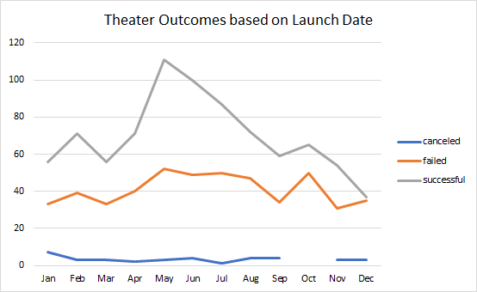

**I faced a challenge using the COUNTIFS formula, I found it long and cumbersome. I had to do referencing and counterchecking it get the right formula.**



1. Results: Answer the following questions in complete and coherent sentences.

What are two conclusions you can draw about the Theater Outcomes based on Launch Date?

**Theater outcome a had high rate of success across all the months with the highest success rate being recorded in the month of May.**

**Canceled activities recorded low numbers with the month of October having no canceled record.**

What can you conclude about the Outcomes based on Goals?

**Outcome based on goals had a high success rate in all the categories apart from 25000 to 29999 and 35000 to 39999 categories.**

What are some limitations of this dataset?

**The data has no previous records that could be used for the comparison.**

What are some other possible tables and/or graphs that we could create?

**From the data we can create a bar graph showing outcome per country and bar graph of parent category per country.**